**Old Business (meeting minutes)**

Attended:

Anthony, Alex B, Alex L, Jiaro, Joe

Missed:

Tony

Sick

** copied from last meeting**

Main requirements

* U/I
* Web crawler mechanism
* Database

Deliverable due on 2/15/2019

* Diagrams
* 1 simple diagram for each functional requirement
* Probably do not need to draw for non functional requirements
* Requirements content
* If we decide to use keywords add it to definitions in part 1
* This way we can reuse keyword definitions without re-explaining each time

Meeting on Friday at 1:30PM

* Meet on UTD campus
* Classroom

** end of copied old business

**Meeting Body**

* Showed new time tracking excel sheet
  + Inside PM Control Mechanisms subfolder
  + Used for time tracking and class presentations at end of semester
* Review document
* Discuss plan for week
* Architectural Patterns
  + Client server
  + Pipe and filter
  + Object oriented

Ideas from Slides

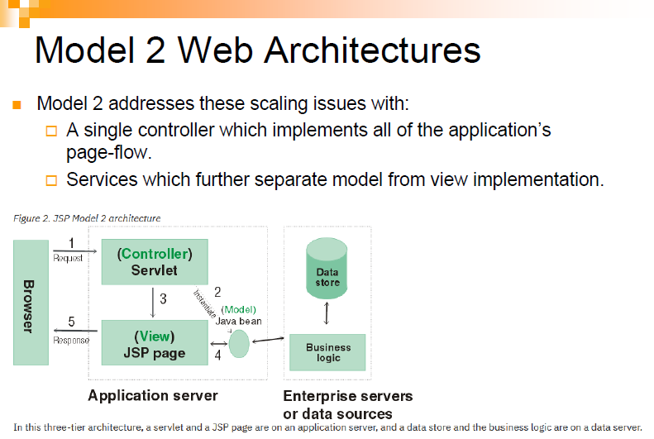

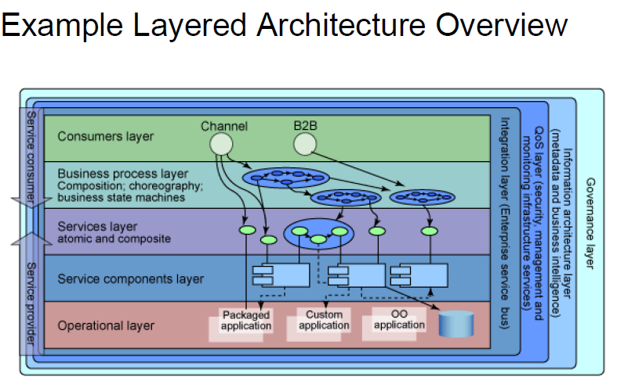

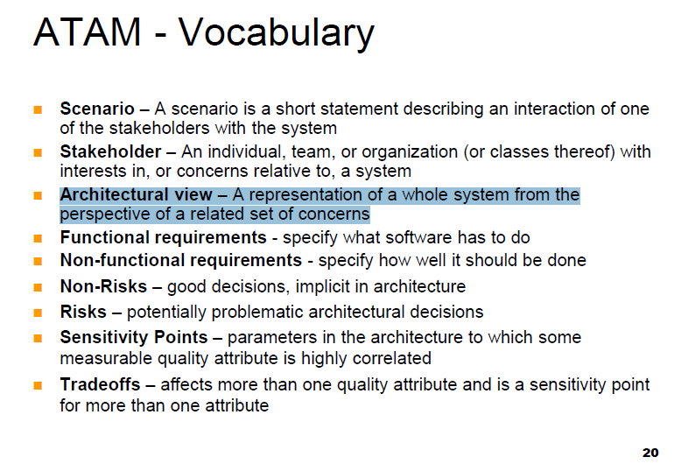

**New Business**

* Think of the architectural type
* Everyone think of the most relevant, but applicable views
  + Database update
  + Webcrawler activated and searching
* Brainstorm sequence diagrams (if possible)
* Meeting in person 02/22/2019